***17.Use the Explicit Cursor to Update the Salary Column as 25% of Basic Salary as Bonus and Update this to get the Net Salary(Department CSE).***

**CREATE TABLE EMPLOYEE3 (EMP_ID INT PRIMARY KEY,EMP_DEP VARCHAR(20),BASIC_SALARY INT,CONSALARY INT,BONUS INT,TAX INT,NET_SALARY INT);**

**INSERT INTO EMPLOYEE3 (EMP_ID,EMP_DEP,BASIC_SALARY) VALUES (1,'CSE',78100);**

**INSERT INTO EMPLOYEE3 (EMP_ID,EMP_DEP,BASIC_SALARY) VALUES (2,'CSE',18145);**

**INSERT INTO EMPLOYEE3 (EMP_ID,EMP_DEP,BASIC_SALARY) VALUES (3,'CSE',30000);**

**INSERT INTO EMPLOYEE3 (EMP_ID,EMP_DEP,BASIC_SALARY) VALUES (4,'CSE',20000);**

**INSERT INTO EMPLOYEE3 (EMP_ID,EMP_DEP,BASIC_SALARY) VALUES (5,'CSE',38000);**

**INSERT INTO EMPLOYEE3 (EMP_ID,EMP_DEP,BASIC_SALARY) VALUES (6,'IT',80000);**

**SELECT *FROM EMPLOYEE3 ORDER BY EMP_ID;**

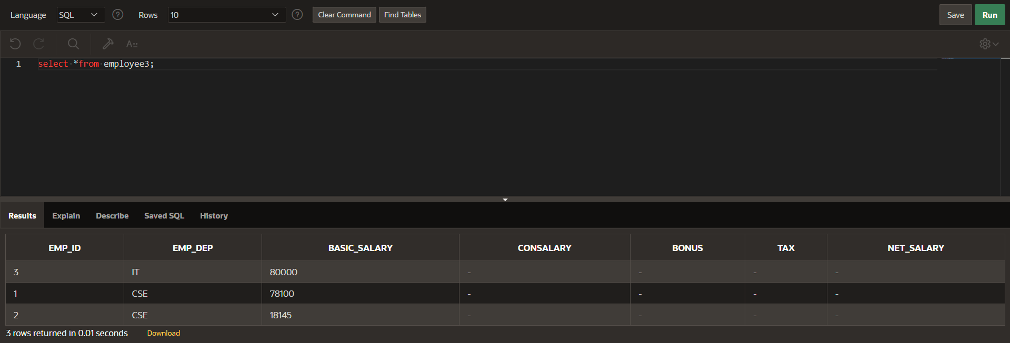

**DECLARE**

**CURSOR cemp IS SELECT EMP_ID, BASIC_SALARY, BONUS, EMP_DEP FROM EMPLOYEE3;**

**v_emp_id EMPLOYEE3.EMP_ID%TYPE;**

**v_basic_salary EMPLOYEE3.BASIC_SALARY%TYPE;**

**v_bonus EMPLOYEE3.BONUS%TYPE;**

**v_emp_dep EMPLOYEE3.EMP_DEP%TYPE;**

**v_tax EMPLOYEE3.TAX%TYPE;**

**v_consalary EMPLOYEE3.CONSALARY%TYPE;**

**v_net_salary EMPLOYEE3.NET_SALARY%TYPE;**

**BEGIN**

**UPDATE EMPLOYEE3 SET BONUS = BASIC_SALARY * 0.25 WHERE EMP_DEP = 'CSE';**

**OPEN cemp;**

**LOOP**

**FETCH cemp INTO v_emp_id, v_basic_salary, v_bonus, v_emp_dep;**

**EXIT WHEN cemp%NOTFOUND;**

**IF v_emp_dep != 'CSE' THEN**

**v_bonus := 0;**

**END IF;**

**IF v_basic_salary < 20000 THEN**

**v_tax := 0.1 * v_basic_salary;**

**v_consalary := 0.12 * v_basic_salary;**

**ELSIF v_basic_salary >= 20000 AND v_basic_salary < 50000 THEN**

**v_tax := 0.2 * v_basic_salary;**

**v_consalary := 0.16 * v_basic_salary;**

**ELSE**

**v_tax := 0.3 * v_basic_salary;**

**v_consalary := 0.21 * v_basic_salary;**

**END IF;**

**v_net_salary := v_basic_salary + v_consalary + v_bonus - v_tax;**

**UPDATE EMPLOYEE3**

**SET TAX = v_tax,**

**CONSALARY = v_consalary,**

**NET_SALARY = v_net_salary**

**WHERE EMP_ID = v_emp_id;**

**END LOOP;**

**CLOSE cemp;**

**END;**

**SELECT *FROM EMPLOYEE3 ORDER BY EMP_ID;**

